New Game Studio
Super Level Optimizer Manual

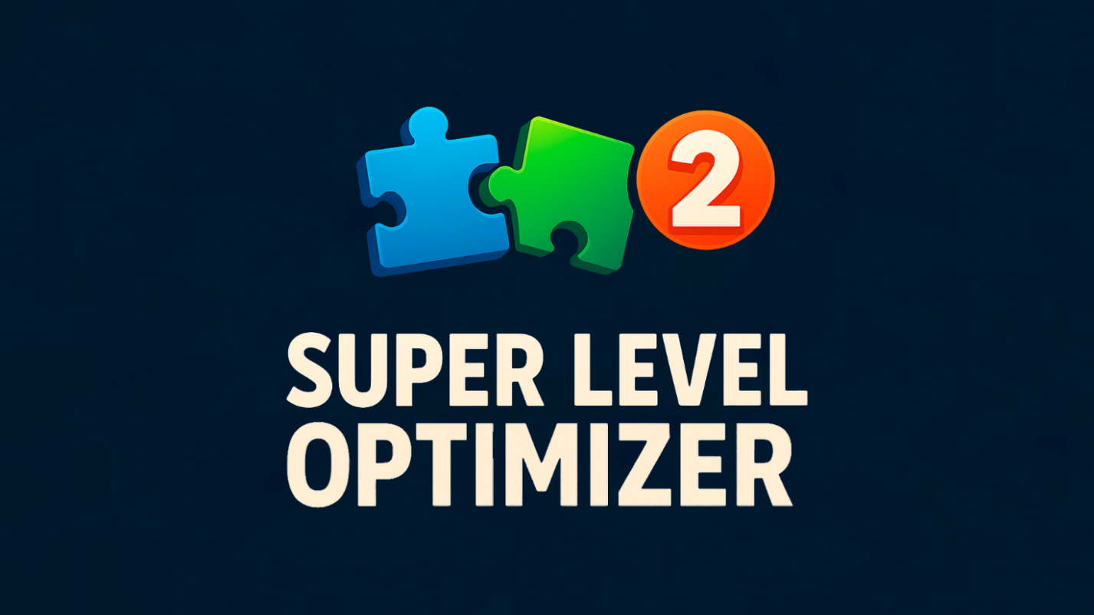

Contact and Support

If you have any questions regarding the use of ACS or any of my other assets, feel free to contact me through any convenient method:

Asset Store Page : https://assetstore.unity.com/publishers/9290
Discord : https://discord.gg/6EYUn9QhXF
Website : http://thenewgamestudio.com/
YouTube : https://www.youtube.com/@NewGameStud1o
Mail : andre-orsk@yandex.ru

Introduction
Thank you very much for choosing Super Level Optimizer 2. We hope it assists you in developing your project.
Super Level Optimizer 2 is a tool designed to boost performance by combining materials and meshes. This process reduces the number of draw calls, resulting in an increase in frames per second (FPS).
The tool consists of three main components:
- MaterialsCombiner: Combines materials by creating texture atlases.
- MeshesCombiner: Merges meshes that share the same materials into a single mesh.
- AssetsExporter: Saves the data generated by MaterialsCombiner and MeshesCombiner into project files.

Materials Combiner
Setup
To add a MaterialsCombiner to your scene, navigate to the menu:
Tools -> NGSTools -> Super Level Optimizer 2 -> Materials Combiner.

Selection Tool
This section provides options for selecting objects in the scene to be processed by the MaterialsCombiner:
- Show Renderers: Displays the renderers added to the combiner in the scene.
- Include Only Static: Limits selection to static objects (those marked as static in the game engine).
- Include MeshRenderers: Includes objects with MeshRenderer components.
- Include SkinnedMeshRenderers: Includes objects with SkinnedMeshRenderer components.
- Add Automatic: Automatically searches the scene for objects suitable for combining.
- Add Selected: Adds all currently selected objects in the scene.
- Remove All: Removes all objects currently added to the combiner.
- Remove Selected: Removes only the selected objects from the combiner’s list.

Shader Properties Edit
Clicking the button opens the Shader Properties settings window, where you can customize how shader properties are combined for each mesh.
- Allow Combine Flag: For each shader, you can set this flag. If set to false, materials using that shader will not be combined.
- Main Texture: Specify which texture should be considered the "main" one. The final resolution of the texture atlas will be determined based on this texture.
- Threshold for Non-Texture Properties: For properties like floats or colors (e.g., Metallic), you can set a threshold. If the difference between two materials’ property values is less than this threshold, they can be combined.
Example: If the threshold is 0.5, and MaterialA has Metallic = 0.1 while MaterialB has Metallic = 0.2, the difference (0.1) is less than 0.5, so these materials can be combined for this property.

Backup Options
- Revert All: Undoes all combined materials and restores the original materials.
- Destroy All: Deletes all backup data created during the combining process.

Combine Options
These settings control how materials are combined into texture atlases:
- Texture Packer: Choose between two packing algorithms:
  - CustomPacker: Uses inner padding for efficiency. For example, three 1024x1024 textures with a padding of 4 pixels might fit into a 4096x4096 atlas.
  - UnityPacker: May result in a larger atlas size compared to CustomPacker.
- Max Atlas Size: Sets the maximum resolution allowed for the texture atlas.
- Max Tile Upscale: Controls how much a texture with tiling can be enlarged in the atlas to preserve its tiling effect. For instance, a 512x512 texture with tiling=2 will be upscaled to 1024x1024. This parameter sets the maximum upscale factor.
- Max Tile Downscale: Determines the maximum amount a texture can be reduced in size to fit the atlas. For example, if set to 2, a texture can be downscaled to half its original resolution.
- Padding: Defines the number of pixels between textures in the atlas. Increasing padding can help prevent visible artifacts, especially at long distances.
- Fill Empty Textures: If two materials share the same shader but one lacks a texture (e.g., a NormalMap), enabling this option replaces the missing texture with an empty one to allow combining.
- Save Assets: When enabled, saves the created atlases and materials as project assets. If disabled, the data is stored in memory and the scene instead.

Materials Combined Output
- Show Combined: Highlights all objects in the scene that were successfully combined.
- Show With Errors: Highlights objects that encountered errors during the combining process.
- Destroy All Reports: Removes all combination-related data components from the scene.
Meshes Combiner
Setup
To add a Meshes Combiner to your scene, navigate to the menu:
Tools -> NGSTools -> Super Level Optimizer 2 -> Meshes Combiner.
Selection Tool
This section provides options for selecting objects in the scene to be processed by the Meshes Combiner:
- Draw Selected: Highlights the added objects in the scene.
- Include Only Static: Limits selection to static objects (those marked as static in the game engine).
- Include MeshRenderers: Includes objects with MeshRenderer components.
- Include SkinnedMeshRenderers: Includes objects with SkinnedMeshRenderer components.
- Include LODGroups: Adds LOD (Level of Detail) groups.
- Add Automatic: Automatically searches the scene for objects suitable for combining.
- Add Selected: Adds all currently selected objects in the scene.
- Remove All: Removes all objects currently added to the combiner.
- Remove Selected: Removes only the selected objects from the combiner’s list.

Combine Options
These settings control how meshes are combined:
- Split Into Groups: Determines whether to divide the scene into cells. Combining objects in smaller groups (rather than all at once) is useful because it allows Frustum Culling and Occlusion Culling to function effectively, reducing the number of vertices rendered per frame.
- Draw Groups: Visualizes how the scene is divided into groups.
- Cell Size: Defines the size of each cell in the division grid.
- Limit 65k Vertices: Limits the number of vertices per mesh to 65,000. This is a constraint often required for mobile devices.
- Lightweight Buffers: Uses smaller vertex attributes, which can reduce the memory usage of the meshes.
- Save Assets: When enabled, saves the created combined meshes as project assets. If disabled, the data is stored in memory and the scene instead.
- Update Groups: Applies the current settings and updates the visualization of the created groups.

Sources Management
- Draw Sources: Highlights the original objects in the scene that were used in the combining process.
- Enable Sources: Enables the original objects and disables the combined objects.
- Add To Ignore All Sources With Errors: Adds all sources that encountered errors during combining to an ignore list. These objects will be ignored in future combining attempts.
- Clear Sources Info: Clears all information about the sources from the scene. After clearing, some functions like "Enable Sources" and "Destroy Sources" will no longer be available.
- Destroy Sources: Removes all components from the scene that were combined (e.g., MeshRenderers and MeshFilters).

Combine Output
- Enable Sources: Enables the original objects and disables the combined objects.
- Destroy Combined Objects: Deletes all created combined objects from the scene.

